1. Create ec2 instance
2. Create s3 bucket
3. Create a role (IAM role with AmazonS3FullAccess))

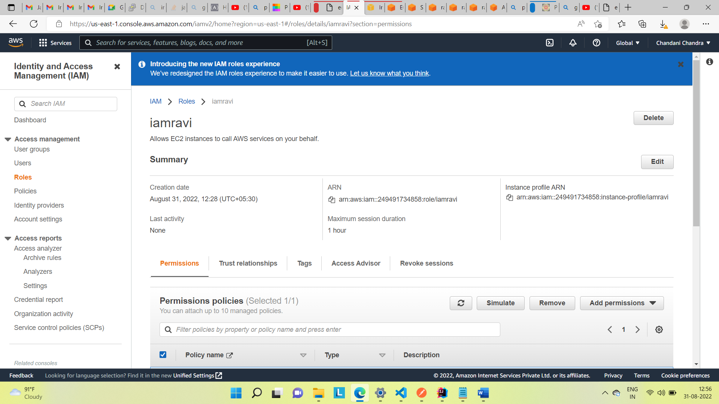

Configure that role with ec2 instance created and then start the ec2 instance .

Goto modifyiam role and select that under that ec2 instance .

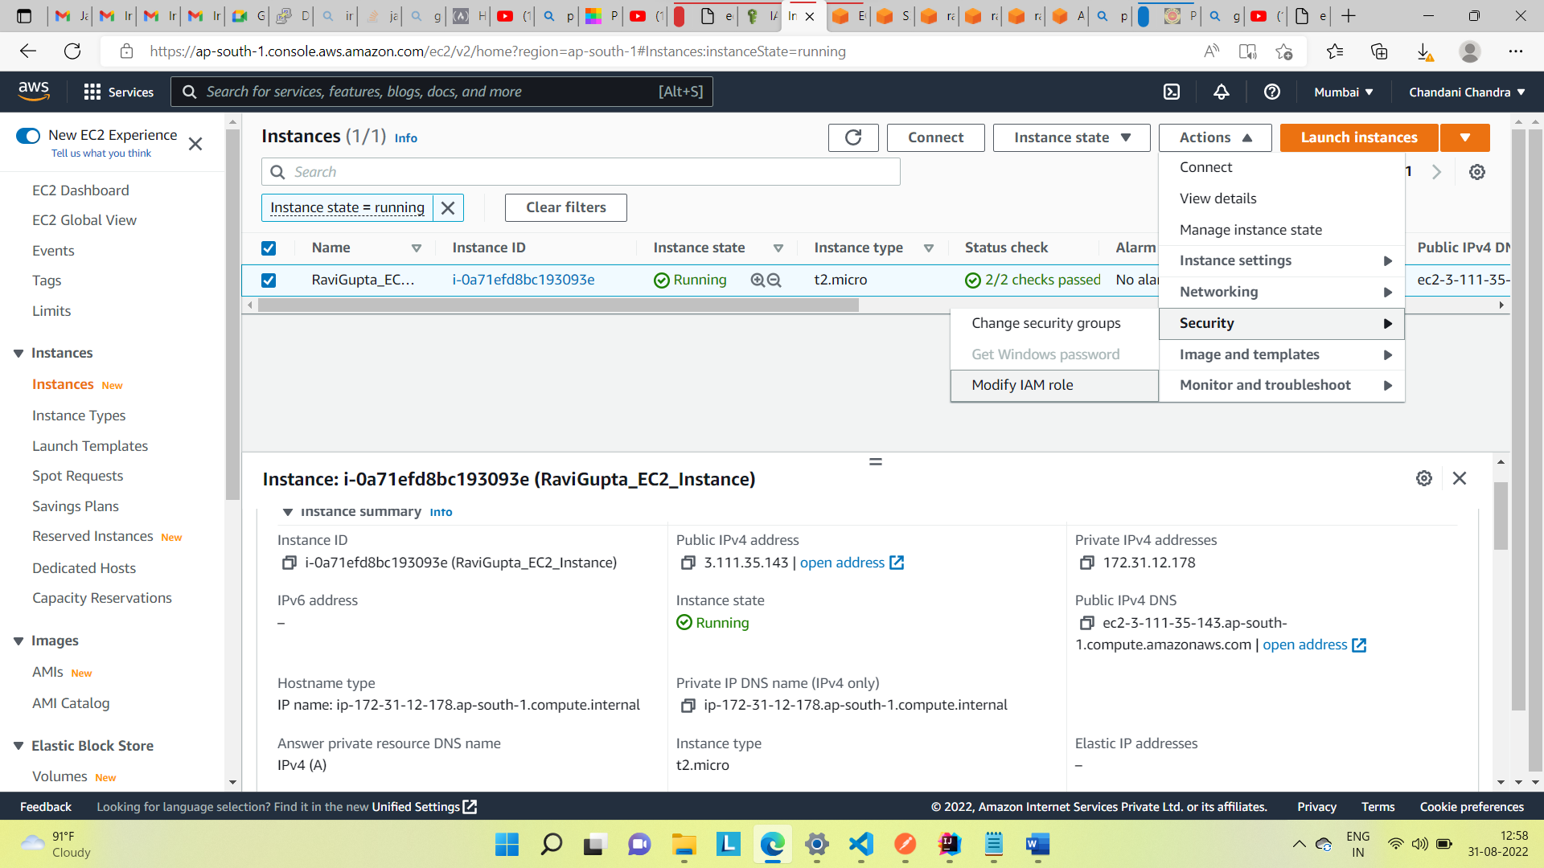

Role is done ,now we can start the ec2 instance .

To connect to ec2 instance you can select the ec2 instance and do connect and that will open up the termimal like this where you can run all the command .

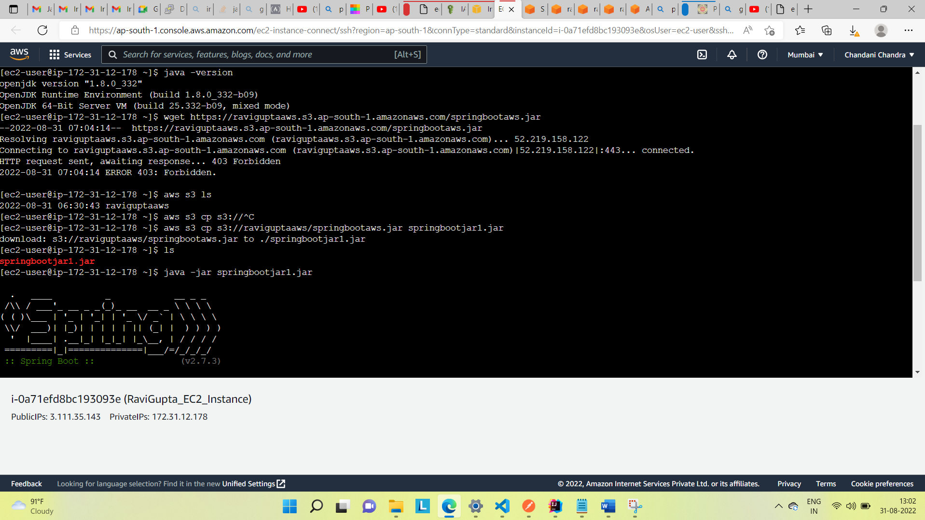

[ec2-user@ip-172-31-12-178 ~]$ aws s3 ls :-command to see all buckets in your account.

2022-08-31 06:30:43 raviguptaaws

[ec2-user@ip-172-31-12-178 ~]$ aws s3 cp s3://raviguptaaws/springbootaws.jar springbootjar1.jar:- command to download the jar file in ec2 instance with name springbootjar1.jar

download: s3://raviguptaaws/springbootaws.jar to ./springbootjar1.jar

[ec2-user@ip-172-31-12-178 ~]$ ls :- command to see if its downloaded in ec2 instance or not.

springbootjar1.jar

[ec2-user@ip-172-31-12-178 ~]$ java -jar springbootjar1.jar run that jar file now .

And the output will be like this .

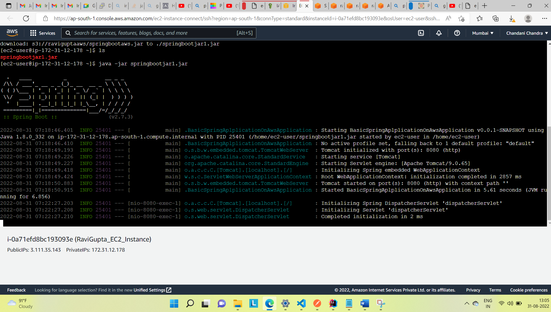

Once its started running we can go to the ec2 instance and get the public ip from here .

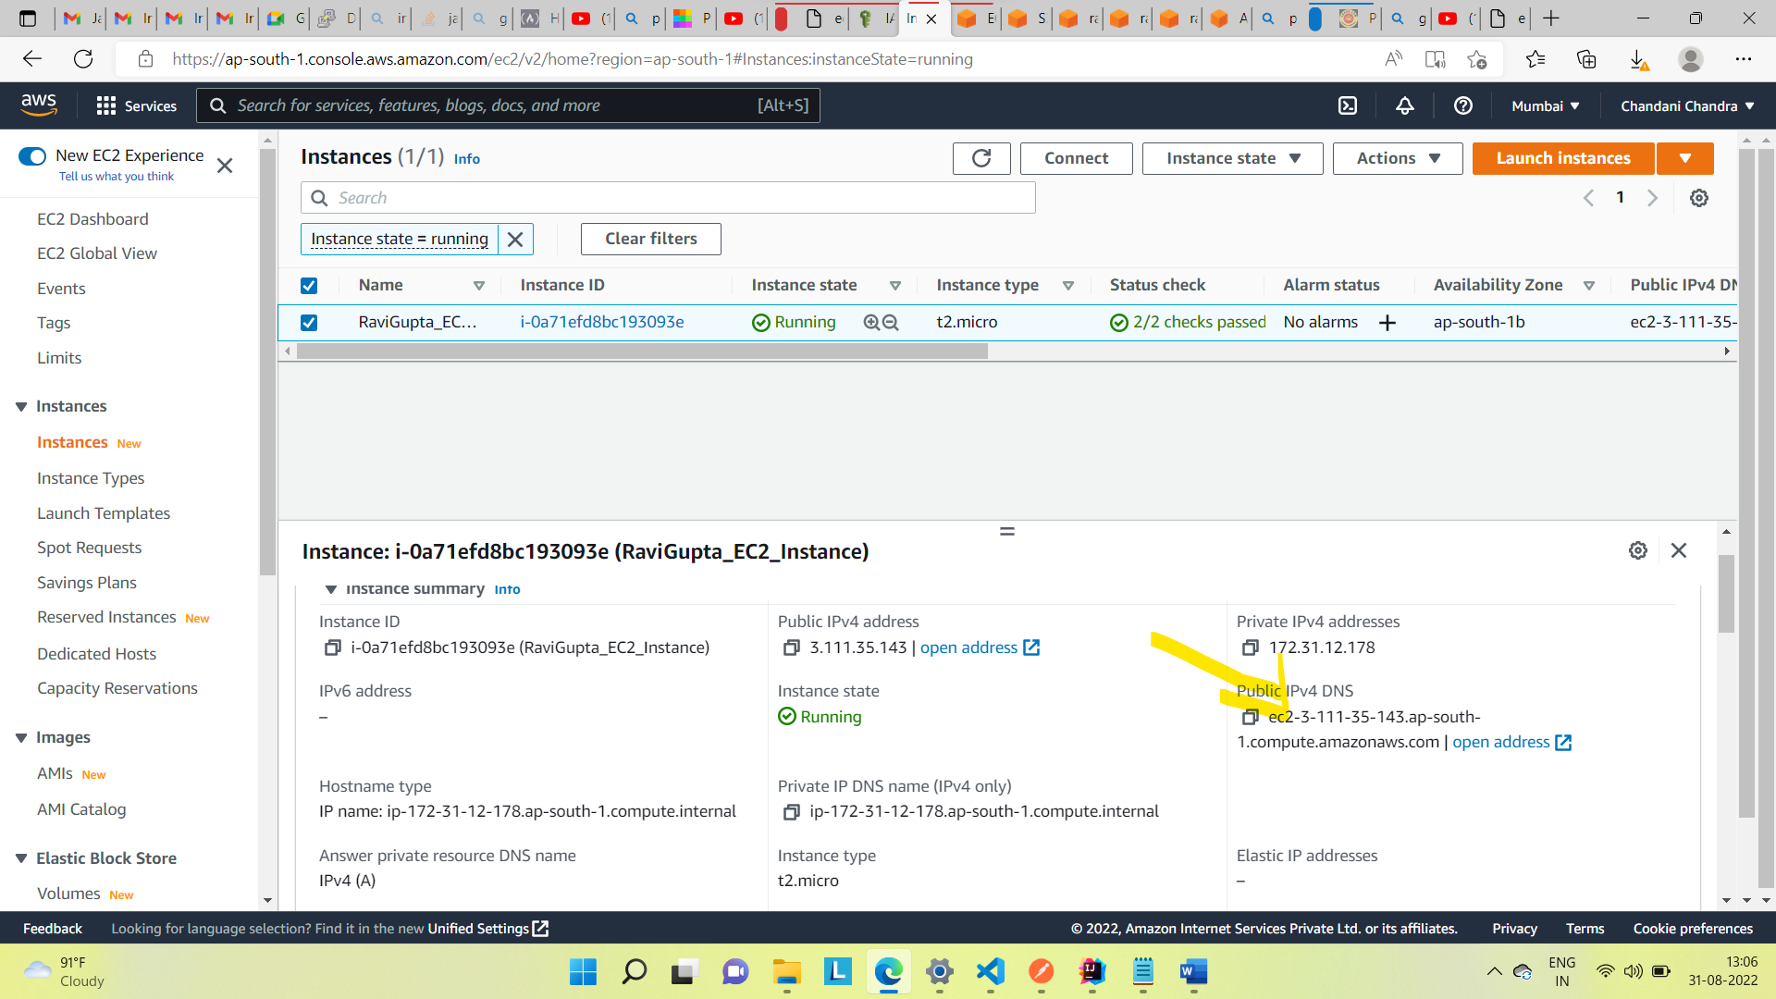

We can use that and provide the port no and try in the browser

[ec2-3-111-35-143.ap-south-1.compute.amazonaws.com:8080](http://ec2-3-111-35-143.ap-south-1.compute.amazonaws.com:8080/)/

output :-

